TRADE OF
Pipefitting

PHASE 2

Module 3

Pipe Processes

UNIT: 6

Pipe Threading and Testing


In cooperation with subject matter expert:

Finbar Smith

© SOLAS 2014
Table of Contents
Unit Objective 1
Learning Outcome 2
1.0 Pipe Thread Types and Designations 3
1.1 Introduction to Pipe Threads 3
1.2 Types of Pipe Threads 3
1.3 British Standard Pipe (BSP) Thread 4
1.4 National Pipe Thread (NPT) 4
1.5 Sealing a Tapered Thread 5
2.0 Pipe Threading Equipment 6
2.1 Hand Held Threading Handle 6
2.2 Threading Dies 7
2.3 Hand Held Threading Machine 7
2.4 Threading Machine 8
2.5 Threading Oils 9
2.6 Sealing Tape 9
2.7 Threading Sealants 9
3.0 Hazards and Safety Precautions Associated with Pipe Threading 10
3.1 General Safety Precautions for Pipe Threading Equipment 10
3.2 Safety Precautions for Threading Equipment 11
4.0 Making and Assembling Threaded Joints 13
4.1 Equipment Required for a Manual Threaded Joint 13
4.2 Cutting the Thread 13
4.2 Assembling the Threaded Joint 14
5.0 Pressure Testing Piping Systems 15
5.1 Pressure Testing Pipework Systems 15
5.2 Test Packs for Pipework Systems 15
5.3 Preparation of Piping System for a Pressure Test 16
5.4 Piping Pressure Test 16
Exercises 20
Additional Resources 21

Unit Objective
There are seven Units in Module 3 for Pipe Processes. Unit 1 focuses on Piping Materials, Unit 2; Piping components and fittings, Unit 3; Bill of Materials, Unit 4; Pipe Preparation, Unit 5; Pipe Joining, Unit 6; Pipe threading and testing and Unit 7 Pipe bending.
Module 3

Pipe Processes
Unit 1

Pipe Materials
Unit 2

Piping Component and Fittings
Unit 3

Bill of Materials
Unit 4

Pipe Preparation
Unit 5

Pipe Joining
Unit 6

Pipe Threading and Testing
Unit 7

Pipe Bending
In this unit you will be introduced to the methods of threading pipe, the different threading equipment used and relevant health and safety behaviour guidelines for the threading processes. You will also be introduced to how to successfully execute a pressure test on a piping system and the recognized operating procedures for a safe pressure test.

Learning Outcome
By the end of this unit each apprentice will be able to:
- Identify the 2 main types of thread specifications that are applicable to the pipe fitting industry.
- List the types of pipe threading equipment in common use in the pipefitting trade and their application.
- Identify the hazards associated with electric threading machines and how to minimise or eliminate these hazzards.
- Complete threading exercises to produce a leak proof threaded joint.
- Identify the different types of pressure tests for piping systems
- Identify the preparation steps for pressure testing a piping system and the procedure required to perform a hydraulic and pneumatic pressure test.
- Thread mild steel pipe sections using manual stocks and dies to dimensions as specified in Exercise No. 2.3.6a.
- Set up electric threading machine, then cut, thread and ream mild steel piping exercises as specified in Exercise No. 2.3.6b.
- Measure, cut, thread, assemble and pressure test piping projects using manual hand tools and threading equipment as specified in Exercise Nos. 2.3.6c, 2.3.6d and 2.3.6e.
- Measure, cut, thread, assemble and pressure test piping project using electric threading machine as per Exercise No. 2.3.6f.

1.0 Pipe Thread Types and Designations

Key Learning Points
- Describe the purpose of Pipe Threads
- Identify the two most common standards for pipe threads
- Identify how threaded pipe joints are sealed

1.1 Introduction to Pipe Threads
A pipe thread is a spiral ridge on the end of a pipe that enables pipes to be joined together. For male fittings, pipe thread appears on the outer diameter of the pipe; if female, the pipe thread appears on the inner diameter. By rotating a male pipe end into a female pipe thread, the two fittings become joined. Since male and female pipe thread must align successfully to form a connection, manufacturers follow pipe thread industry standards. The two main pipe thread standards are as follows:
- The British Standard Pipe thread (BSP)
- The American National Pipe Thread (NPT)

1.2 Types of Pipe Threads
Pipe threads are used to make not only a mechanical joint but also a leakproof liquid seal. This is accomplished by machining the thread form on a taper and using pipe sealant to fill any voids between the two threads which could cause a spiral leak. In both thread standards there are 2 different types of threads:
- Parallel ('straight') threads, BSPP (British Standard Pipe Parallel Thread), which have a constant diameter; denoted by the letter G.
- Taper threads, BSPT (British Standard Pipe Taper Thread), whose diameter increases or decreases along the length of the thread; denoted by the letter R.
A parallel pipe thread only forms a mechanical seal and is not used for liquid seal applications. While a tapered pipe thread that can make a close-fitting wet seal. Pipe threads used for liquid joints can be divided into two types:
- Jointing threads: These are pipe threads where pressure-tightness is made through the mating of two threads together. They always use a taper male thread, but can have either parallel or taper female threads and the seal is usually secured with a sealant compound. (In Europe, taper female pipe threads are not commonly used.)
- Fastening threads: These are parallel pipe threads used where a pressure-tight joint is achieved by the compression of a soft material (such as an o-ring seal, gasket or a washer) between the end face of the male thread and a socket or nipple face, with the tightening of a backnut.

1.3 British Standard Pipe (BSP) Thread
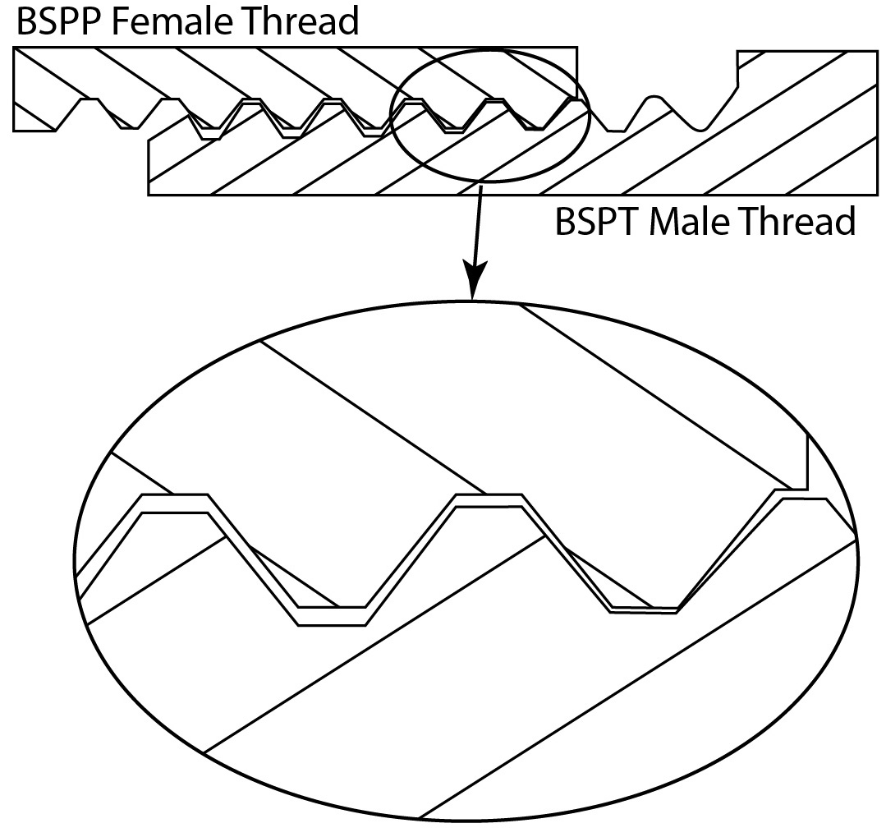
In the nineteenth century, many different types of screw threads were required for hydraulic and pneumatic circuits as well as fastening components. As a result, manufacturers started to devise their own fastening systems. This resulted in compatibility problems. The English mechanical engineer and inventor, Sir Joseph Whitworth devised a uniform threading system in 1841 to address the incompatibility problem. The Whitworth thread form is based on a 55 degree thread angle with rounded roots and crests. The joint is made self sealing by cutting at least one of the threads on a taper (usually the male thread). This became known as the British Standard Pipe thread has been adopted internationally for interconnecting and sealing pipe ends. The image below shows a BSPT (BSP Taper) male thread sealing in BSPP (BSP Parallel) female coupling.
BSPT male sealing in BSPP female
To achieve the taper the bottoms of the threads aren't on a cylinder, but on a cone; with a taper which is 1⁄16 inch in an inch, which is the same as 3/4 inch in a foot. The taper divided by a centre line yields an angle 1° 47' 24" or 1.7899° as measured from the centre axis. Commonly-used sizes are ⅛, ¼, ⅜, ½, ¾, 1, 1¼, 1½, and 2”, available at most suppliers. Larger sizes are used less frequently because other methods of joining are more practical for 3” and above in most applications.
The most important point to understand about pipe threads is that their size refers to the diameter of the hole going through the fitting (i.e. where the media travels such as air or oil, etc), and not the diameter of the thread itself.

1.4 National Pipe Thread (NPT)
In America, William Sellers set the standard for nuts, bolts, and screws which became the National Pipe Tapered Thread (NPT) in 1864. His 60 degree thread angle with flat crests and roots is the American standard for tapered threads used to join pipes and fittings. The ANSI/ASME standard B1.20.1 covers threads of 60-degree form in sizes from 1/16” to 24” Nominal Pipe Size (NPS).
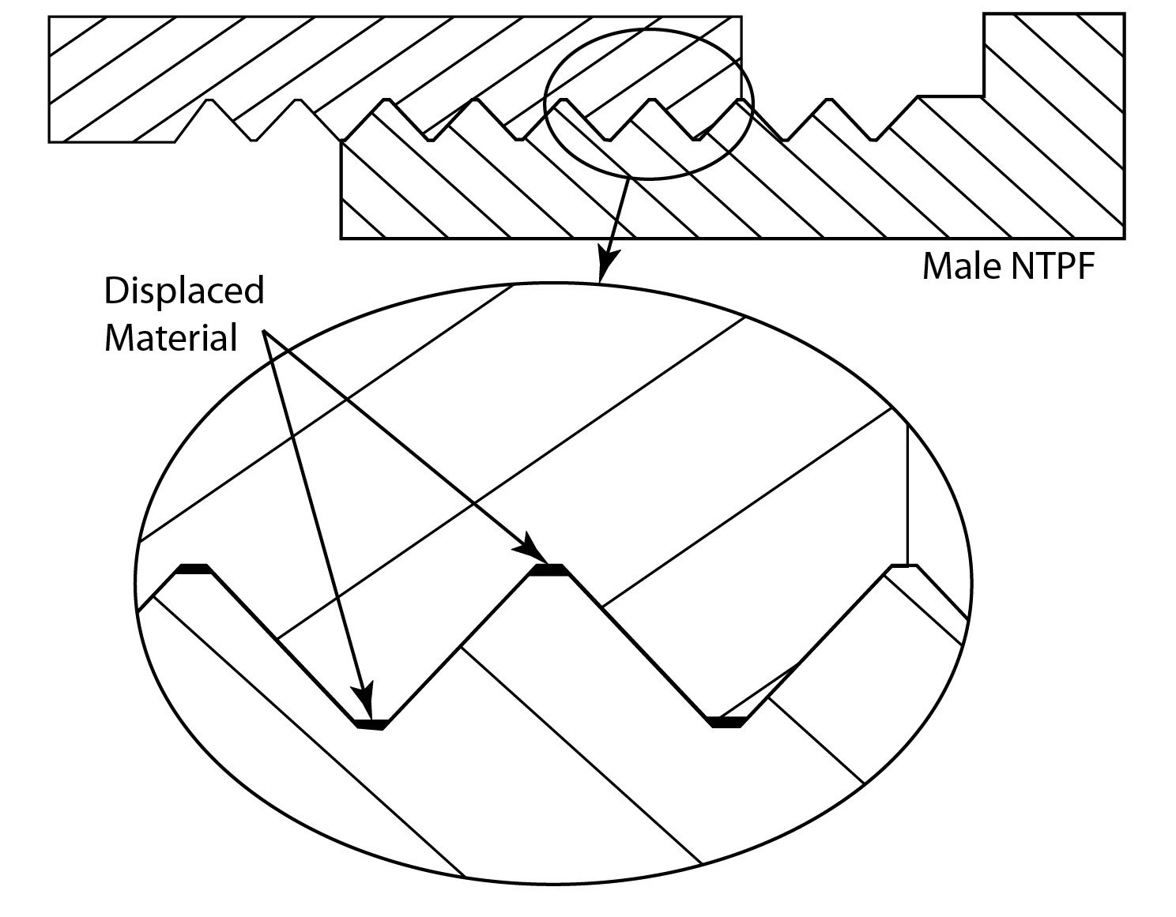
The taper rate for NPT threads is the same as BSPT (3/4” per foot) measured by the change of diameter (of the pipe thread) over distance. Sometimes NPT threads are referred to as MPT ('Male Pipe Thread'), MNPT, or NPT(M) for male (external) threads; and FPT ('Female Pipe Thread'), FNPT, or NPT(F) for female (internal) threads.
NPT male sealing in NPT female (Hand tight plus 1 turn)

1.5 Sealing a Tapered Thread
Because of the taper, a pipe thread can only screw into a fitting a certain distance before it jams. The standard specifies this distance as the length of hand tight engagement, the distance the pipe thread can be screwed in by hand. It also specifies another distance – the effective thread, this is the length of the thread which makes the seal on a conventional machined pipe thread. For pipefitters, instead of these distances, it is more convenient to know how many turns to make by hand and how many with a wrench. A simple rule of thumb for installing tapered pipe threads, both metal and plastic, is finger tight plus one to two turns with a wrench. Torque installation values can be determined per application, but due to the variations involved in pipe joints such as disimiliar materials of male and female threads, type of sealants used, and internal variations in product wall thickness, a standard torque specification cannot be generically applied. The table below compares the critical dimensions of BSP and NPT threads and gives the number of turns to hand tighten.
 | British BSP |  | American NPT
Nominal Size | Actual OD | Threads per inch | Actual OD | Threads per inch | Turns for a hand tight joint
1/8" | 0.383” | 28 | 0.405” | 27 | ≈ 3.3 turns
1/4" | 0.518” | 19 | 0.540” | 18 | ≈ 3.1 turns
3/8" | 0.656” | 19 | 0.675” | 18 | ≈ 3.3 turns
1/2" | 0.825” | 14 | 0.840” | 14 | ≈ 3.4 turns
3/4" | 1.041” | 14 | 1.050” | 14 | ≈ 3.7 turns
1" | 1.309” | 11 | 1.315” | 11.5 | ≈ 3.7 turns
1 1/4" | 1.650” | 11 | 1.660” | 11.5 | ≈ 3.8 turns
1 1/2" | 1.882” | 11 | 1.900” | 11.5 | ≈ 3.8 turns
2" | 2.347” | 11 | 2.375” | 11.5 | ≈ 3.9 turns
Comparison of BSP v NPT threads and turns to hand tighten

2.0 Pipe Threading Equipment

Key Learning Points
- Identify manual equipment used for threading pipe
- Identify threading machines used for threading pipe
- Describe the purpose of threading oils and sealants

2.1 Hand Held Threading Handle
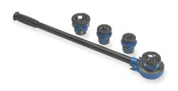
A hand held threading handle is made up of a stock to which the handles are attached and to which the cutting die is inserted in. There are two sets of set screws on the stock, one set for holding the dies in place and the other set for adjusting the dies. On the stock there is a deep mark to correspond with the standard thread mark on the dies. On the opposite side of the stock there is a place for the follower which helps to guide the cutting dies onto the pipe that is to be threaded. The photos below are typically representative of manual threading handles.
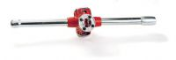
Manual threading handles, ratchets and cutting dies
A threading ratchet has only one handle and a ratchet action which allows it to be used in confined spaces. Their size and convenience makes it possible for pipefitters to cut a section of pipe and add the right configuration of threads to pipes while at the job site or clean up an existing thread which had become damaged.

2.2 Threading Dies
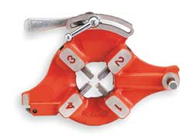
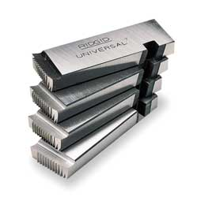
A full set of stocks and dies is composed of right and left dies from 1⁄8” up to 1”, with a guide for each size. The dies will have marked on them 1" R which will cut a 1” right handed thread, (if 1-inch left were wanted, the mark would be 1" L).
Die head and set of universal cutting dies for a range of thread sizes
A threading machine uses a set of universal machine dies which are fixed in the die head and are numbered to be inserted in the correct sequence. One set of these dies can cut a range of pipe sizes usually from 1” to 2” threads and 2½” to 4” threads. The photos above show a die head with the positions numbered and a set of universal dies for cutting threads on 1” to 2” pipe.

2.3 Hand Held Threading Machine
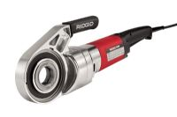
Portable handheld electric units are relatively inexpensive, lightweight and are ideal for maintenance and repair workers, as well as service plumbers. They can thread pipe from 1/8” to 2" in diameter and usually come in a durable carrying case with a set of 6 right hand dies to cover all common pipe sizes in this range.
Hand held threading machine for light work 1/8” to 2”

2.4 Threading Machine
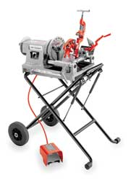
At one time, pipe threading machines were the province of large scale manufactures and tended to focus on the mass production of threaded steel pipes. Along with machining the specified thread design, the machines would also cut the pipe into workable sections, as well as ream out the pipe to ensure there were no defects in the pipe proper. Over time, the process for pipe threading and pipe cutting was refined, making it possible to produce completed goods for sale in a very short period of time. The uses of machines allow the threading process to produce uniform pipe threads that are uniform in nature.
Workshop threading machine with foot pedal control
For heavier duty or high volume repetitive work a pipe fitter would typical use a power threading machine. This type of machine can thread a wide range of pipe including black, galvanized and plastic-coated pipe, together with stainless steel and heavy-wall conduit, as well as rod up to 30 Rockwell C. These types of units typically operate at 36 RPM for 1/4" to 2" pipe and at 12 RPM for 2 1/2" to 4" pipes. There is constant and proper lubrication of dies and the workpiece with through-head oiling and a universal receding die head allows cutting of tapered or straight BSPT/BSPP or NPT/NPSM threads. Motor control Reverse/Off/Forward, is achieved with a heavy-duty rotary-type integral foot switch which allows the pipe fitter have both hands free for the work piece.
Along with increased efficiency and lower maintenance costs, there are pipe threading machines that are designed to work with materials other than metal. Pipes made with various types of plastic or resin materials can now be ran through pipe threading machines with no fear of overheating and thus damaging the finished product. There are many manufactures who use these machines to prepare low cost plastic piping making use of universally recognized thread configurations.

2.5 Threading Oils
Threading oils are used to cool and lubricate the cutting die and work piece. The use of threading oils assists the threading process for the following reasons:
- They keep the threading dies and the workpiece at a stable temperature (critical when working to close tolerances) and therefore improves thread quality.
- Maximize the life of the cutting dies by lubricating the working edge and reducing die ware.
- Reduces threading torque and speeds metal removal.
- Prevent rust on the threading dies and on the machined threads.
There are various kinds of cutting fluids specially formulated to maximize wear resistance and can increases die life up to 60% and significantly reduce operating costs by up to 30%. Like thread sealants they should be selected depending on the piping service being installed and the pipe material being threaded.

2.6 Sealing Tape
The taper on BSPT threads allows them to form a seal when torqued as the flanks of the threads compress against each other, as opposed to parallel/straight thread fittings or compression fittings in which the threads merely hold the pieces together and do not provide the seal. However a clearance remains between the crests and roots of the threads, resulting in a leakage around this spiral. This means that BSPT fittings must be made leak free with the aid of thread seal tape or a thread sealant compound. The most common pipe thread tape is polytetrafluoroethylene or (PTFE) tape. The tape should be wound tight around the male pipe threads, running in the same direction as the lead thread so that the turning motion of joining the pipes follows the tape's winding direction. Sealing tape makes it easy to drive the male pipe deeper by allowing the threads to slip past one another, while filling minute gaps to prevent seepage. Pipe thread tape also makes it easier to disassemble the joint later, if need be, by reducing thread galling, or the tendency of some types of pipe threads to stick together over time.
Special grease free PTFE tape which will not support combustion should be used on threaded joints on oxygen lines as the standard PTFE tape can self ignite when the oils and pure oxygen combine.

2.7 Threading Sealants
Thread sealants can also be used for sealing threaded joints and allow easy disassembly of joints without compromising thread integrity and prevents thread corrosion. There are different types of sealant for different applications depending on the type of pipe, temperature of service and the fluid being carried in the pipe. It is important that sealant being used should non-toxic, lead-free formulas which won’t harden or freeze.

3.0 Hazards and Safety Precautions Associated with Pipe Threading

Key Learning Points
- Identify specific hazards pertinent to pipe threading
- Identify how these hazards are eliminated or minimized
- Identify how hazards towards others are minimized
- Identify safety precautions to be observed while threading pipe.

3.1 General Safety Precautions for Pipe Threading Equipment
When operating pipe threading equipment the operator should be properly trained and supervised and observe all the general safe working procedures required for the threading processes. While this is not meant to be an exhaustive list some specific points to note for pipe threading are as follows:
Always -
- Comply with the prescribed safety precautions and fire-prevention guidelines for the workshop.
- Ensure the threading machine is in sound condition and good working order. Take action for immediate repair or replacement of damaged parts. Use recommended parts only. The use of improper parts may be dangerous and will invalidate the machine warranty.
- Ensure that all dies are in good condition with no worn edged or have points missing.
- Ensure that there is a sufficient supply of clean coolant and that all filters are clean and functioning.
- Do not assemble when tired or when under the influence of drugs or medication.
- DO NOT allow untrained persons to operate threading equipment.
- Keep threading machine and associated parts clean for best and safest performance.
- Wear ANSI-approved safety goggles and heavy-duty work gloves during use.
- As with any machining process, there is a significant pinch hazard created. Keep hands, fingers, feet, and any item which may be injured or damaged away from the threading machine during operation.
- Ensure that there are no loose clothes to snag on rotating parts, that long hair is tied up and all jewelry is removed before commencing work.
- Locate the threading machine in a suitable, well lit working area.
- Keep working area clean, tidy and free from unrelated materials.
- Use on level and solid ground, preferably concrete.
- Ensure all non-essential persons keep a safe distance whilst the threading machine is in use.
- When threading pipe the equipment should be in a horizontal position with sufficient clear space to insert and withdraw the end of the pipe for threading.
- Ensure that the threading machine is set-up with the correct parameters for the pipe material being threaded as brass and cast iron are dry cut without coolant.

3.2 Safety Precautions for Threading Equipment
The following are generic guidelines for pipe threading equipment, as there are many different suppliers of threading equipment it is not possible to provide a specific check list. This information does not replace the manufacturer’s instruction guide, it is meant only to acquaint the operator with some basic functions and safety tips that he/she must be aware of.
Threading equipment varies considerably in their control and safety arrangements and therefore it is important to verify that actual equipment used is set-up correctly.
- Before each use, inspect the threading equipment for damaged components.
- Check that threading dies are set correctly for the pipe size to be threaded.
- Regularly wipe down and clean the tool to keep it in best condition.
- Keep hands away from the die and all other rotating parts when threading pipe.
- Confirm that the recommended coolant is used and that there is an adequate supply and that re-circulation filters are kept clear and clean.
- Ensure that the speed settings are correct for the pipe size being threaded.
- Ensure that long lengths of pipe are properly supported on pipe rollers to prevent any strain on the threading equipment.
- DO NOT operate the threading equipment if damaged.
- DO NOT use the threading equipment for purposes other than that for which it is intended.
- DO NOT overreach. Keep proper footing and balance at all times. Do not reach over or across running machines.
- Check that keys and adjusting wrenches are removed from the tool or machine work surface before plugging it in.
- Avoid unintentional starting. Be sure the switch is in the OFF position when not in use and before plugging in.
- When not in use, store the tool in a clean, dry, safe location out of reach of children and other unauthorized persons.
- Ensure that you read, understand safety instructions before operating the threading equipment.
- Maintain product labels and nameplates. These carry important safety information.
Please refer to your instructor for specific instruction and additional safety information where required.

4.0 Making and Assembling Threaded Joints

Key Learning Points
- Identify the equipment required to complete a threaded joint
- Identify the procedure to form a thread on the end of a pipe
- Identify the procedure to assemble a threaded joint

4.1 Equipment Required for a Manual Threaded Joint
The following tools will be required to complete a threaded joint:
- Threading die and handle to match the size of the pipe.
- Pipe vice
- Pipe cutter
- Reamer for the size pipe being threaded
- Set of pipe wrenches
- Cutting fluid and sealing tape or sealing compound

4.2 Cutting the Thread
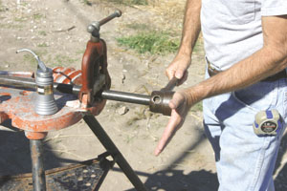
Secure the pipe in the pipe vice and cut to the desired length. Then, fit the threading die over the end of the pipe. The cutting starts with a fine thread on the die, cutting fluid must be used to lubricate the pipe and die. Turn the handle of the die clockwise half a turn at a time, and then back it off a bit in order to eject the metal chips. The dies are run up on the pipe until the pipe extends through the face of the dies one thread. Oil is put on the pipe and the dies at least twice during the cutting. Ensure that the die is kept perpendicular to the pipe at all times to ensure the thread is square and even. The inner threads or those away from the pipe end are not cut as deep, providing a taper that creates a tighter joint. Remove the pipe from the vise, stand it on end, and tap to remove any metal chips or particles that may be lodged inside.
Threading the end of a pipe
Then clean off the oil with a soft rag. Be careful; the threads are very sharp and can cut your hands. Insert the correct size reamer inside the pipe to ensure any sharp burrs are removed from the inside of the pipe.

4.2 Assembling the Threaded Joint
The threaded pieces are then joined together using couplings or fittings. A sealing material must be used on the threads at each joint. This can be either Teflon tape, or a pipe thread sealing compound.
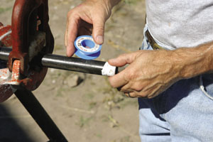
Teflon tape or pipe thread sealing compound is placed on the threads.
With the sealing material in place, hand-tighten the pipe and coupling or fitting. Then, using pipe wrenches, one on the pipe and one on the fitting, tighten one and a half more turns.
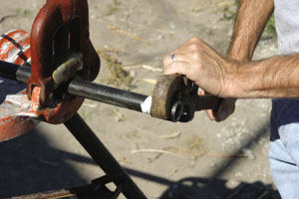
Tighten the coupling or fitting by turning one and a half more turns after hand tight
Steel or galvanized piping is heavy and it must be well supported, especially at each joint or coupling. Use pipe clips at regular intervals and close to threaded joints to ensure that the pipe is well supported and does not sag. CAUTION: It is extremely important to test all joints for leaks. Use a bit of water mixed with dish detergent and a soft brush to coat the solution over all joints. Any bubbles produced indicate a leak. Shut off the gas, retighten the joint and retest.

5.0 Pressure Testing Piping Systems

Key Learning Points
- Identify the 2 main types of pressure test and their applications
- Identify the critical components of a pressure test pack
- Identify what preparations are required prior to raising pressure in a piping system.

5.1 Pressure Testing Pipework Systems
Pressure testing of pipelines should normally be carried out using water. Only in exceptional circumstances should pneumatic pressure testing using compressed inert gas or air be used, and then only under carefully controlled conditions. The reason for this is because water is virtually incompressible (as are other liquids) and only a small quantity of energy needs to be introduced to increase the pressure significantly. Air, however, (like all gases) is compressible and, as a result, much more energy has to be put into the gas to raise its pressure. In fact, at the pressure ranges normally used for testing water-piping systems 200 times more energy is stored in compressed gas compared to water at the same pressure and volume. So, should a joint, pipe, or any other component fail under test pressure when using compressed gas, the energy can be released with deadly force! However, where water leakage would cause unacceptable damage to property, a pneumatic leak test (at approx. 20mbar) with a soap bubble test at all joints can be used first, followed by a hydraulic pressure test.

5.2 Test Packs for Pipework Systems
Before pressure tests are carried out it is important to verify the following:
- Identify the clients design requirements and that any and all testing is in accordance with these requirements.
- Verify that the system is complete as per the P&ID drawing.
- Identify the correct sequence of events which must be completed before testing can commence.
- Identify the correct method of testing and all safety precautions which must be observed during execution of the test.
Test pack drawings and documentation should be submitted to the client or his representative in advance of any testing. This is required to give ample time for the system to be reviewed and the necessary personnel to be notified and work permits to be prepared.

5.3 Preparation of Piping System for a Pressure Test
Prior to execution of any pressure test, a representative for the contractor must complete a pre-test installation check on the pipeline to be tested. A record at this inspection must be completed, signed by the contractor and verified by the client or his nominated representative before testing can commence. This pre-test installation check should include at a minimum (but not be limited to) the following:
- The test area must be cordoned off and all employees in the vicinity be informed to the effect that a hazardous procedure is to be executed. Positions of fire fighting equipment and first aid should be noted in case of emergencies.
- Where possible the contractor shall ensure that pressure testing is carried out during off peak hours to minimise risk to all personnel
- Prior to execution of the test, the contractor shall ensure that all test gauges are calibrated in accordance with the proper procedures and that the accuracy of such gauges shall be traceable to National/International standards.
- No gauge will be subjected to a test pressure greater than their scale value.
- The contractor must ensure that all necessary safety valves and pressure relieving devices have been correctly installed.
- Any equipment or instrumentation which is not to be subjected to the test pressure must be isolated. This should be highlighted on the test pack drawing so the limits of the test are recorded.
- All in-line instruments, sight glasses etc. shall be included in the tests where feasible as long as the test pressure does not exceed the pressure rating of these components.
- Ensure that any valves with the test limits are in the open position.
- The section to be tested shall be completely flushed before tests begin to ensure that no particles are present so as to prevent them from becoming embedded in the walls of the pipeline.
- Upon the successful completion of the test all blinds, plugs and caps etc. used to isolate parts of the line will be removed. New gaskets where applicable will be used and special care shall be taken when re-assembling the pipe line to avoid leaks.

5.4 Piping Pressure Test
Depending on the system specification the finished installation must satisfy one or both of the following tests.
- Hydrostatic Test
- Pneumatic test

Hydrostatic Test
Section of pipe passing through clean or sensitive areas, may be checked for leaks using a low pressure air test prior to undergoing a hydrostatic test if requested by the client.
- Pipeline systems shall be pressure tested to 1.5 times their design pressure unless otherwise agreed with the client or his nominated representative.
- The test pressure when reached will be maintained for a minimum of 1 hour (or longer if required by the system specification).
- The test fluid for hydrostatic tests shall be clean potable water (unless otherwise specified) at ambient temperature, which shall contain no substances which could be detrimental to the material or the process.
- Fill the piping system with water and apply a preliminary test pressure of 1 Bar, or as directed by the Project Engineer. While holding this pressure, vent all remaining air from the piping system at the high point vents and continue to fill with water as necessary to maintain a 1 Bar initial fill pressure.
- Note This pressure should be held for a minimum of 10 minutes to allow for the walk down of the system and the location of any major leaks. If leaks are detected during this step, or at any time during the test, relieve the pressure and take appropriate action to correct the leak. If necessary, consult the Project Engineer for instruction.
- Apply the hydrostatic test pressure in increments of 1 Bar, or as directed by the Project Engineer, until the maximum test pressure is reached. Hold pressure for 5 minutes at each 1Bar increment and inspect for leaks before adding more pressure.
- The system shall be monitored to ensure that the desired pressure (to within 0.1 Bar) is achieved and that allowances are made for thermal expansion and contraction of the system.
- Note: It is very important to allow for thermal equalisation before starting the 1 hour test period. Cooling of the test fluid will cause it to contract and therefore the pressure in the system will fall without any leak in the system.
- Hold the maximum test pressure for 1 hour and get the client to witness it and sign the necessary documentation.
- Note the specification should indicate allowable test tolerances which are permissible to account for thermal differences and the size of a piping system under test.
- Upon successful completion of the test, the system shall be vented slowly, drained and all end points blanked and capped.

Pneumatic Test
- The test fluid for pneumatic tests shall be clean dry air unless otherwise agreed with the client or his nominated representative.
- Apply a preliminary test pressure of 1 Bar, or as directed by the Project Engineer.
- Note This pressure should be held for a minimum of 10 minutes to allow for the location of any major leaks. If leaks are detected during this step, or at any time during the test, relieve the pressure and take appropriate action to correct the leak. If necessary, consult the Project Engineer for instruction.
- Apply the test pressure in increments of 0.5 Bar, or as directed by the Project Engineer, until the maximum test pressure is reached. Hold pressure for 5 minutes at each 0.5 Bar increment to allow the system to equalise strains and to test joints with a soapy water solution before adding more pressure.
- Enough time will be left between steps.
- Note: The maximum test pressure shall be 1.5 times the maximum system operating pressure. For systems that derive their pressure from hydrostatic pressure, the required test pressure will be verified prior to testing by the Project Engineer or the Field Engineer.
- Hold the maximum test pressure for 1 hour and get the client to witness it.
- Remove the pressure, with caution to avoid escaping air stream, debris, and high decibel noise level.

Safety and repairs
- Repair work, if necessary shall be carried out only when the pipeline has been de-pressurised and optimum working conditions obtained. When the failed area is repaired the system shall be tested again using "original test pressures and procedures".
- No vessel or pipeline shall endure shock loading or hammer testing while in a pressurised state.
- No vessel may be approached for close examination during the test. If close examination is required this may only occur when the pressure is at 80% of the design pressure.
- Pressure shall be released gradually and always from the highest point of the system.
The table below indicates the typical information recorded on a pressure test certificate and the verification steps and signatures required.
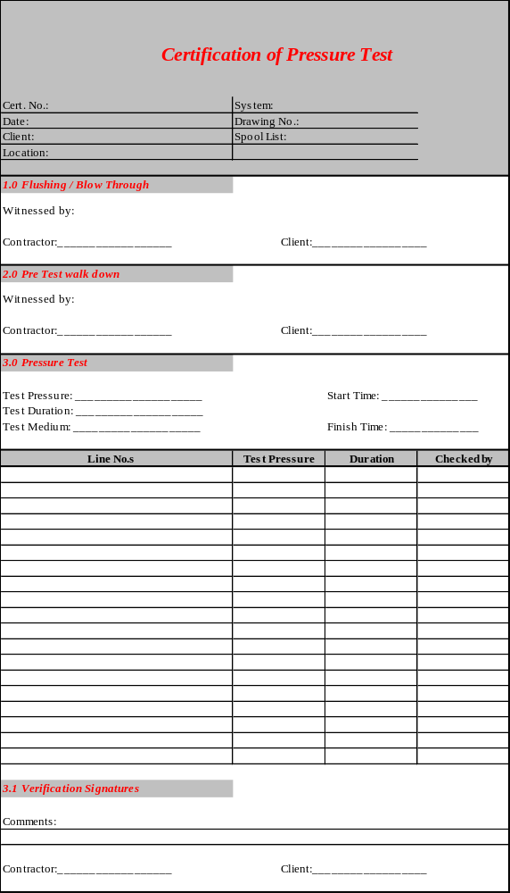Typical Pressure test certificate with sign offs for each step

Exercises
- Set up electric threading machine, then cut, thread and ream mild steel piping exercises as specified in Exercise No. 2.3.6b.
- Measure, cut, thread, assemble and pressure test piping projects using manual hand tools and threading equipment as specified in Exercise Nos. 2.3.6c, 2.3.6d and 2.3.6e.
- Measure, cut, thread, assemble and pressure test piping project using electric threading machine as per Exercise No. 2.3.6f.
- Identify 3 reasons why cutting fluids are used when cutting threads on pipe.
- Why is PTFE tape or sealing compound used on threaded joints?
- State why it is important to ensure that the test fluid is at ambient temperature when carrying out a pressure test.

Additional Resources
- Nayyar, P.E., Mohinder L. (2000). "A1". in Mohinder L. Nayyar, P.E.. Piping Handbook (7th ed.). New York: McGraw-Hill. ISBN 0-07-047106-1.
- David L. Goetsch (2000). Technical Drawing (5th ed.). Thompson Delmar Learning ISBN: 1-4018-5760-4
- International standard ISO 7-1: Pipe threads where pressure-tight joints are made on the threads — Part 1: Dimensions, tolerances and designation. International Organization for Standardization, Geneva.
- BS EN 10226: Pipe threads where pressure tight joints are made on the threads. (The European version of ISO 7.)
- Part 1: Taper external threads and parallel internal threads — Dimensions, tolerances and designation.
- Part 2: Taper external threads and taper internal threads — Dimensions, tolerances and designation.
- BS 21: Pipe threads for tubes and fittings where pressure-tight joints are made on the threads (metric dimensions). British Standards Institution, 1985. (Superseded by BS EN 10226:2004).
- International standard ISO 228-1: Pipe threads where pressure-tight joints are not made on the threads — Part 1: Dimensions, tolerances and designation.
- BS 2779: Specification for pipe threads for tubes and fittings where pressure-tight joints are not made on the threads (metric dimensions), 1986.
- BS EN 10226-1:2004
- ASME B31.9 Building Services Piping; 937 – Leak Testing, 1996 Edition
- Elements of Plumbing by Samuel Edward Dibble, 2010

Castleforbes House
Castleforbes Road
Dublin 1

